TUNKU ABDUL RAHMAN UNIVERSITY OF MANAGEMENT AND TECHNOLOGY
FACULTY OF COMPUTING AND INFORMATION TECHNOLOGY
BMDS2123 NATURAL LANGUAGE PROCESSING 202605
Assignment Title: BorakBot: A Knowledge-Based Bahasa Rojak Chatbot with Speech Input
Programme: RDS - Bachelor in Data Science (Honours)
Tutorial Group: 4
Lecturer/Tutor's Name: Dr. Chong Jin Hui
Date of submission: Week 12 (Friday – 5 September 2026, before 11.59 pm)

Team Members:
No | Student Name | Student ID | Signature | Marks (For Lecturer / Tutor use)
1. | Ng Yong Vay | 25WMR09608 | ngyongvay
2. | Teo Pei Qi | 25WMR09625 | teopeiqi

Student Declaration of Originality
We confirm that we have read and shall comply with all the terms and conditions of TAR University of Management and Technology plagiarism policy.
We declare that this assignment is free from all forms of plagiarism and for all intents and purposes is our own properly derived work.

Name: | Ng Yong Vay | Teo Pei Qi
Photo:
Signature: | ngyongvay | teopeiqi

Module and Task Handled by Each Team Member and Contribution
No. | Team Member | Task(s) Completed | Contribution (%)
1. | Ng Yong Vay | Speech test-set design and stratification; audio conversion pipeline; WER evaluation harness; language-routing design, diagnosis and threshold sensitivity analysis; JPJ knowledge-base domain; corpus generation prompt and validator; QLoRA configuration and training run; similarity evaluation harness (perplexity, BLEU, chrF, ROUGE-L, BERTScore); error analysis and reporting. | 50%
2. | Teo Pei Qi | Bahasa Rojak utterance authoring and validation; speech recording; orthography map construction from substitution analysis; results verification; JPN, Immigration, slang and small-talk knowledge-base domains; out-of-scope probe design and corpus review; Stage 2 transcription-repair table and module; Streamlit interface and Stage 4 feedback loop; refusal and hallucination-control evaluation; reporting. | 50%

Table of Contents
Student Declaration of Originality 2
Module and Task Handled by Each Team Member and Contribution 2
Table of Contents 3
1.0 Introduction 5
Objectives Addressed 5
2.0 Research Background 6
2.1 Code-switching is not solved by language identification alone 6
2.2 Malaysian resources: rule-based normalisation against regionally pretrained models 6
2.3 Chatbot architecture, and what a generative answer costs 6
2.4 Adapting a large model on free hardware 7
2.5 Synthetic data where no corpus exists 7
2.6 Correction from users, and why it is not applied automatically 7
2.7 The research gap 8
3.0 Methodology 10
3.1 System overview and workflow 10
3.2 Data collection 11
3.3 Preprocessing 11
3.4 NLP techniques and models 12
3.5 Implementation and environment 12
3.6 Evaluation design 13
4.0 Pseudocode 14
4.1 Speech-to-text with language routing 14
4.2 Evaluation procedure 14
4.3 Transcription repair 14
4.4 Knowledge-based generation with trained refusal 15
4.5 Feedback capture and moderated retraining 15
5.0 Algorithm Analysis 16
5.1 Test set and evaluation metric 16
5.2 Configurations compared 16
5.3 Language selection and threshold sensitivity 17
5.4 Error analysis and assessment against the target 19
5.5 Knowledge base, corpus and the split 20
5.6 Selecting the base model by measurement 21
5.7 Fine-tuning configuration and the loss curve 21
5.8 Generation quality against the un-fine-tuned base 23
5.9 Hallucination control and residual failures 24
6.0 Coding 25
6.1 Language routing 25
6.2 Corpus WER 25
6.3 Transcription repair 25
6.4 Knowledge-based generation 26
6.5 Feedback capture 27
6.6 Repository structure 27
7.0 Results 28
7.1 Headline measurements 28
7.2 Stage 1: speech recognition 29
7.3 Stage 3: generation and hallucination control 29
7.4 Achievement against the project objectives 30
8.0 Discussion and Conclusion 31
8.1 What the findings mean 31
8.2 Strengths of the solution 31
8.3 Limitations 32
8.4 Conclusion 32
9.0 References 34
Appendices 36
Appendix A: Declaration of AI tool assistance 36
Appendix B: Prompt text used for decoder conditioning 36
Appendix C: Orthography map (lenient scoring) 36
Appendix D: Test set categories and speaker allocation 37
Appendix E: Transcription repair table 38
Appendix F: System prompt 39
Appendix G: Prototype Interface 40

1.0 Introduction
The problem. Malaysians rarely speak or write Malay or English on its own. Everyday conversation is Bahasa Rojak: a Malay sentence carrying English nouns, an English sentence closed with lah or kan, prices and agency names switching language mid-clause. Systems built for one language at a time handle this badly. A speech recogniser must commit to a language before it transcribes, and the wrong choice returns a translation instead of a transcript, losing the particles that carry the speaker's meaning. A model trained on formal text replies in the wrong register, and on Malaysian government procedure it either does not know the answer or invents one. The people most likely to ask how to renew a road tax or replace a lost MyKad are the least likely to phrase the question formally, so the difficulty falls on exactly the users a public-information service exists for.
Why this needs an NLP solution, and which one. The information is not the obstacle. JPJ, JPN and Immigration all publish it, but formally, in one language at a time, and across separate portals, while the question arrives spoken, mixed and informal. Closing that gap is a language problem at every stage. None of the three standard chatbot architectures is free: a rule-based system cannot survive rojak's spelling variance, a retrieval-based one is accurate but cannot rephrase into the user's language mix, and a generative one does both and pays in hallucination. BorakBot takes the generative route and buys back control by fine-tuning a small open model on a verified knowledge base and training refusal from examples rather than filtering it at the output, so register and knowledge boundary are learned together.
BorakBot is a knowledge-based conversational agent that accepts Malay-English code-switched speech and text, and replies in the same informal register. It runs in four stages: speech-to-text, transcription repair, generation by a QLoRA fine-tuned language model, and a human-in-the-loop correction loop. This report documents the design, implementation and evaluation of all four.

Objectives Addressed
- Objective 1: Accept Malay-English code-switched input, as text and as speech.
- Objective 2: Reply in the same rojak register.
- Objective 3: Keep replies knowledge-based, declining questions outside the curated knowledge rather than inventing an answer.
- Objective 4: Integrate speech-to-text so users can converse by voice.
- Objective 5: Embed the knowledge base in the model by fine-tuning, with no retrieval at inference.
- Objective 6: Capture user corrections for moderated retraining.
- Objective 7: Evaluate the system with appropriate quantitative metrics, speech errors reported apart from NLP errors.

2.0 Research Background
Each subsection below restates the Part A (proposal) background that bears on the delivered system, then records what the implementation actually found.

2.1 Code-switching is not solved by language identification alone
Early work treated language identification as a prerequisite: tag each word's language, then route it to a monolingual model. Sitaram et al. (2020) expose the weakness of that pipeline, since word-level identification is itself unreliable on romanised, informally spelled text and its errors cascade. Winata et al. (2021) take the opposite position, letting multilingual models absorb code-switching implicitly; their models beat monolingual ones on code-switched benchmarks while still trailing on pure-language tasks. Lim et al. (2021) propose a framework for Malay-English mixed-language question answering, confirming the demand and the difficulty, but stop at framework level.
What this project found. Whisper predicts one language token per segment, which is language identification by another name, and it was the dominant Stage 1 error source rather than the acoustic model. Splitting identification and transcription across two checkpoints cut WER from 0.398 to 0.349 (§5.3). What remains is calibration, not deafness: the detector hears English in all eight English-dominant clips but scores them at a median 0.234 against a 0.5 threshold.

2.2 Malaysian resources: rule-based normalisation against regionally pretrained models
Two generations of Malaysian NLP resources coexist with complementary limitations. The Malaya toolkit (Zolkepli, 2018) offers informal-Malay normalisation, but its normaliser is dictionary- and rule-driven: it handles catalogued abbreviations and cannot generalise to novel slang. Khalip et al. (2025) find that even large models degrade on noisy Malay input. The newer generation, including Mesolitica's Malaysian checkpoints, is pretrained on regional text such as Manglish, so slang is learned rather than listed; the inverse weakness is that a generative model offers no guarantee of controlled output.
What this project found. Part A planned to layer the two, cleaning input with Malaya before generation. Measurement made that untenable, since 73% of training inputs contain informal rojak markers and expanding shortforms would move them off the distribution the adapter was fitted on (§3.3). The regionally pretrained speech checkpoint earned its place (0.398 against 0.447); the regionally pretrained language model did not, fabricating a JPJ regulation and offering legal advice (§5.6). Regional pretraining bought fluency, not control.

2.3 Chatbot architecture, and what a generative answer costs
Chen et al. (2017) set out the standard taxonomy. Rule-based systems are predictable but brittle to paraphrase, and rojak's spelling variance multiplies the pattern space past maintainability. Retrieval-based systems are controllable but robotic, and cannot rephrase into the user's language mix. Generative systems are fluent and handle paraphrase, at the price of hallucination. Lewis et al. (2020) reduce that price with retrieval augmentation, but the added infrastructure exceeds what this assignment requires alongside speech.
What this project found. A fine-tuned generative model was adopted, with refusal trained from 130 corpus examples rather than filtered at the output. It works, but only when measured correctly. Both the tuned and untuned models decline about 82% of out-of-scope questions; the untuned one gets there by declining 67% of the questions it should have answered. The gap between those rates is what describes a boundary, and it moved from 15 percentage points to 80 (§5.9).

2.4 Adapting a large model on free hardware
LoRA (Hu et al., 2021) changed the economics of adaptation by training low-rank adapters over frozen weights, and QLoRA (Dettmers et al., 2023) went further by quantising the frozen base to 4-bit while training those adapters, cutting memory by roughly two-thirds at negligible quality cost. LLaMA-Factory (Zheng et al., 2024) lowered the engineering barrier again with YAML-driven configuration and native QLoRA support.
What this project found. The economics hold: a 3B-class model was adapted in 160 steps and 45 minutes on a free T4, producing a 24 MB adapter over a 6 GB base, with held-out perplexity falling from 23.75 to 3.65 (§5.8). Less expected was that the standard heuristic misleads here. Validation loss bottomed out at step 100 and rose 13% by the end, which normally means stop early; because the objective is memorising a fixed knowledge base, it is a proxy rather than the goal (§5.7).

2.5 Synthetic data where no corpus exists
No public Manglish dialogue corpus exists. Malaysian corpus work has concentrated on sentiment, and Shamsuddin et al. (2024) document how automated labelling of Malay-English data produces skewed and partly false labels. Model-generated instruction data (Wang et al., 2023; Taori et al., 2023) is the pragmatic alternative, and the literature is clear about its failure modes: distributional narrowing, style contamination, self-reinforcement.
What this project found. Narrowing appeared in a form the general warning does not describe: the generator padded by reusing one question frame across sixteen facts, changing only the quoted term. Sixteen distinct strings, one question, invisible to exact-match deduplication. A second finding is arithmetic: a fact stating a single value supports five to seven distinct questions, not ten, so the proposal's target of 165 facts by ten paraphrases assumed a yield that does not exist.

2.6 Correction from users, and why it is not applied automatically
A system that learns from user corrections inherits whatever it is told. The proposal took the position that an unmoderated loop is worse than no loop at all, and specified periodic, team-reviewed batches with no automatic write path into the training data.
What this project found. The first correction the system ever logged was a negative verdict on a correct refusal: it had properly declined to explain photosynthesis, and the tester supplied an answer for it. Applied automatically, that one correction would have taught the model to answer science questions and eroded the boundary the evaluation exists to measure.

2.7 The research gap
Read column-wise, Table 1 exposes the gap. Code-switching research stops at classification benchmarks, dialogue and retrieval research stops at English, and Malaysian NLP research stops at sentiment and annotation. No study combines them into an implemented, evaluated, speech-enabled mixed-language dialogue system with a moderated correction loop.
Study | Context | What it established | What it left open, and this project's answer
Sitaram et al. (2020) | Code-switched speech and language, survey | Language-identification errors cascade into every downstream stage | Cascade shown in a deployed pipeline: Whisper's per-segment language token, not its acoustic model, was the dominant Stage 1 error source (§5.3)
Winata et al. (2021) | Multilingual pretrained models on code-switching | Implicit multilingual handling outperforms monolingual models | Not conversational, and no Malay-English speech. Implicit handling kept, but utterance-level routing added, worth 5 WER points (§5.3)
Lim et al. (2021) | Malay–English mixed-language question answering | A conceptual framework for the task | Never implemented or measured. This project implements and evaluates one
Zolkepli (2018) | Malay language toolkit | Rule-based normalisation of informal Malay | Dictionary-bound. Measured here: with 73% of training inputs in informal rojak, expanding shortforms moves input off the fitted distribution (§3.3)
Khalip et al. (2025) | Noisy Malay text, LLM prompting | Large models degrade on noisy Malay input | Understanding only. This project generates in rojak as well as reading it
Radford et al. (2023) | Weakly supervised multilingual ASR | One language token is predicted per 30-second segment | Consequence for switching named but not quantified. Quantified here: forced Malay scores 0.788 on English-dominant clips against 0.106 under the correct token (§5.3)
Chen et al. (2017); Lewis et al. (2020) | Dialogue system taxonomy; retrieval-augmented generation | Architecture trade-offs; retrieval reduces hallucination | English-only, and hallucination treated as a rate. Measured here as the gap between out-of-scope and in-domain refusal, 15 to 80 points (§5.9)
Hu et al. (2021); Dettmers et al. (2023); Zheng et al. (2024) | Parameter-efficient fine-tuning | LoRA and QLoRA make 3B-class adaptation feasible on free-tier hardware | No low-resource code-switched dialogue case study. Supplied here: 160 steps, 45 minutes, a 24 MB adapter, perplexity 23.75 to 3.65
Wang et al. (2023); Taori et al. (2023); Shamsuddin et al. (2024) | Synthetic instruction data; Malay–English annotation | Generation is viable where no corpus exists; quality risks are documented | Failure modes uncharacterised for fact-grounded code-switched corpora. Two characterised here: template reuse invisible to exact-match deduplication, and a paraphrase yield of five per single-value fact
Table 1: Related work, and what each left open. The right-hand column states this project's answer and where the evidence for it appears.

3.0 Methodology

3.1 System overview and workflow
BorakBot is a four-stage pipeline with an offline preparation track. The runtime path runs on every user turn; the preparation track runs before deployment and produces the adapter the runtime path loads. No corpus and no retrieval step is consulted at inference: the knowledge lives in the model's weights, and the rest of this methodology follows from that. Appendix G shows the interface exercising each stage.
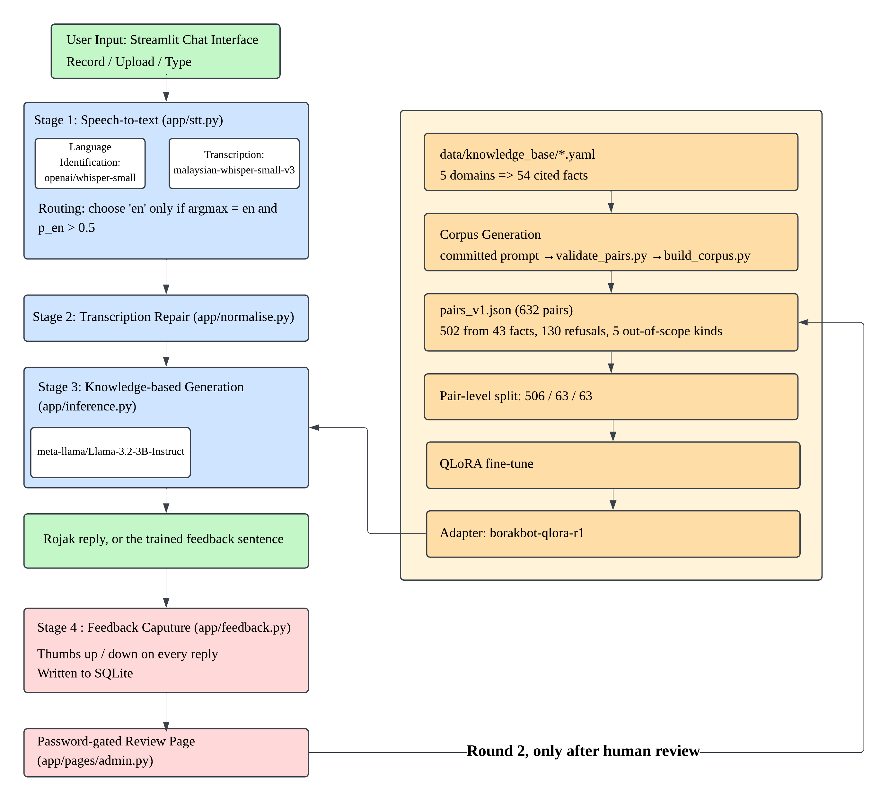
Figure 1: BorakBot system architecture. The runtime path (left) runs on every user turn; offline preparation (right) and the moderated correction loop are dashed because neither executes at inference.
Stage 1: Speech-to-text with language routing. The user types rojak or speaks. Base Whisper makes one encoder pass over the audio and returns an English probability, which selects the language token used for transcription. Transcription runs on mesolitica/malaysian-whisper-small-v3 with a short-code-switched sample as decoder context.
Stage 2: Transcription repair. The transcript passes through a seventeen-entry repair table covering only tokens Whisper invents that exist in neither language. Register, capitalisation and punctuation are left untouched.
Stage 3: Knowledge-based generation. The repaired utterance, the last two dialogue turns and a system prompt read from the knowledge base go to Llama-3.2-3B-Instruct, loaded in 4-bit with the QLoRA adapter applied. Decoding is greedy and capped at 160 new tokens. Questions outside the curated domains get a trained fallback sentence, not an invented answer.
Stage 4: Feedback capture. Every reply carries a verdict control. A negative verdict opens a correction field, and the exchange is written to SQLite with its dialogue context, backend and latency. A password-gated review page exports thumbs-down rows shaped like training pairs; a person decides which become training data.
Two aspects of Stage 4 are deliberate. The transcript and the model input are stored in separate columns, so a wrong answer to a misheard question counts against Word Error Rate rather than the generation metrics. And corrections are never applied automatically: there is no retraining trigger and no write path into the training data.

3.2 Data collection
No public Bahasa Rojak corpus exists for either speech or dialogue, so all three datasets were built by the team.
The knowledge base. 54 facts across five domains (JPJ vehicle licensing, JPN identity documents, Immigration passports, Malaysian slang and small talk), written as YAML with a source and stability marker each: 39 verified against official agency portals, 15 from secondary sources. Facts rather than conversations are the unit, because a fact can be checked against a portal. Verification was not ceremonial: every aggregator reports RM120 for non-citizen licence renewal, while the official JPJ table gives that as the trial rate and the competent driving licence as RM60.
The speech test set. 48 utterances across six switch-type categories (Malay-dominant, English-dominant, balanced intra-sentential, discourse particles, numerals, Malaysian named entities), eight per category, 387 reference words. References were written before recording, since transcribing our own audio afterwards would have biased them. Speakers were balanced within each category, so a poor category score cannot be blamed on one voice.
The training corpus. 632 question-answer pairs generated from the 54 facts by a prompted large language model: 502 answering from the knowledge base, and 130 answering an out-of-scope question with the fallback sentence. Refusal pairs are not padding, since refusal is the hallucination control the proposal specifies and a model learns it from examples. Generation is declared in Appendix A.

3.3 Preprocessing
Audio. Phone recordings are converted to mono WAV and paired to their manifest rows by filename rather than by position, because copying files off a phone rewrites modification times.
Text at inference. Only transcription repair. The substitution table produced by the WER evaluation cannot be reversed into a repair table: it records what each reference word turned into, not what each mistake came from, and Whisper wrote saya for can, do, i, balance and my. What can be repaired is the residue that is not a word in either language.
Why not normalisation. Part A specified informal-Malay normalisation here, and measurement made that untenable. 371 of the 506 training inputs (73%) contain informal rojak markers and the adapter was fitted on that register, so expanding shortforms first would move every input off it. The same evidence rules out Part A's other two operations: capitals are load-bearing, since case-folding P to p erases a probationary licence class, and 391 of the 506 inputs contain a question mark. Stage 2 therefore repairs what Stage 1 got wrong and leaves the register alone, as Appendix E records.
Text for scoring. Reference and hypothesis are lowercased, stripped of punctuation and whitespace-collapsed before alignment. Two scores are reported: strict, which counts orthographic variants as errors, and lenient, which first canonicalises a documented set of same-word spelling variants. Translations are excluded, because a transcript in formal Malay is still wrong for the stage that follows.

3.4 NLP techniques and models
Each choice below was settled by measurement reported in §5.0, not by preference.
Language identification: openai/whisper-small. One encoder pass, used only to choose a language token. Base Whisper rather than the Malaysian checkpoint, because the latter pins Malay in its generation configuration and its detector is the defect being worked around.
Transcription: mesolitica/malaysian-whisper-small-v3. Same architecture and parameter count as openai/whisper-small, distilled on Malaysian speech including Manglish. Selected on 0.398 against 0.447 at equal prompt conditions.
Generation: meta-llama/Llama-3.2-3B-Instruct. Chosen over a Malaysian-pretrained candidate that read as more fluent, because its failure mode was over-refusal from ignorance, which fine-tuning repairs, while the alternative's was fabrication, which nothing in the training plan removes.
Adaptation: QLoRA. 4-bit NF4 with double quantisation over frozen weights, rank 16 and alpha 32, adapters on all attention and MLP projections, five epochs at a 2e-4 cosine schedule. Configuration and reasoning in §5.7.
Evaluation: two metric families. Word Error Rate as corpus totals for speech; perplexity, BLEU, chrF, ROUGE-L and BERTScore for generation. BERTScore uses a multilingual encoder because the references are code-switched, and chrF is included as a character-level cross-check on word-level BLEU over short answers.

3.5 Implementation and environment
The application is four Python modules plus a Streamlit interface and a password-gated review page. Feedback is stored in SQLite; the adapter is published to the Hugging Face Hub and never committed to the repository, as with all weights and audio.
Training runs on Google Colab with a free T4, checkpointing to Drive so a run survives disconnection. This deviates from the proposal, which named Kaggle Notebooks: Kaggle gates notebook networking behind phone verification the team account could not complete. The change is environmental and affects no reported figure.
The demonstration machine has 4 GB of video memory, which the two models cannot share. The language model gets the GPU because it is thirteen times larger and runs once per reply rather than once per clip. The speech model is pinned to the CPU, where it costs a few seconds that are invisible beside generation and the transcript is identical, since the computation is float32 either way.
The arithmetic forces that choice. The 4-bit model needs about 2.4 GB for weights plus 0.6 GB for CUDA context and cache, the speech model 1 GB more, and the Windows display reserve about 0.3 GB, so the total exceeds the card.
Without a GPU the system still runs, loading in bfloat16 on the CPU at roughly 70 seconds per reply against roughly 7 seconds for the 4-bit GPU path, as the reply captions in Appendix G record. The interface reports which backend produced each reply and how long it took.

3.6 Evaluation design
Two independent harnesses were built and their results are never combined. A wrong answer to a misheard question is a different failure from a wrong answer to an understood one, and merging them would make neither diagnosable.
Speech. Nine configurations across two factors (model and decoder prompt) plus the language token, evaluated over all 48 clips. Word Error Rate is reported as total errors divided by total reference words, not as the mean of per-clip rates, which over-weights short utterances.
Generation. The corpus is split 506 / 63 / 63 at the level of the pair rather than the fact. A fact-level split would ask whether a model with no retrieval component generalises to facts it was never taught, which has a known answer. The pair-level split measures whether a fact learned from one phrasing survives being asked in another, so every generation figure here is paraphrase robustness. Refusal is measured separately, because all refusal items share one gold answer.

4.0 Pseudocode

4.1 Speech-to-text with language routing
INPUT : audio file (16 kHz mono WAV)
OUTPUT : transcript in the language actually spoken
CONSTANT ROJAK_PROMPT <- short code-switched sample, Malay and English words
each in their own orthography

PROCEDURE Transcribe(audio):
// Stage 1a: language identification -- base Whisper, one encoder pass
probs <- VanillaWhisper.DetectLanguage(LogMel(PadOrTrim(audio, 30 s)))
p_en <- probs['en'] // recorded for the sensitivity analysis
IF Argmax(probs) = 'en' AND p_en > EN_THRESHOLD THEN lang <- 'en'
ELSE lang <- 'ms' // asymmetric: a wrong 'en' is unbounded
// Stage 1b: transcription -- Malaysian checkpoint, prompted
tokens <- MalaysianWhisper.Generate(Encode(audio), language = lang,
task = 'transcribe', context = Tokenise(ROJAK_PROMPT))
RETURN StripEchoedPrompt(Decode(tokens), ROJAK_PROMPT)

4.2 Evaluation procedure
INPUT : manifest of (audio_path, reference, switch_type, speaker)
OUTPUT : corpus WER per configuration and per switch type

PROCEDURE Evaluate(manifest, configurations):
FOR EACH config, clip DO
Store(config, clip.id, Transcribe(clip.audio, config))
FOR EACH stored (reference, hypothesis) DO
r, h <- Normalise(reference), Normalise(hypothesis)
(S, D, I, N) <- Align(r, h) // subs, deletions, insertions, ref words
Accumulate(errors += S + D + I, words += N)
// Corpus WER, NOT the mean of per-clip rates, which over-weights
// short utterances.
RETURN errors / words

4.3 Transcription repair
INPUT : transcript string from Stage 1
OUTPUT : same utterance, invented tokens repaired, register unchanged
CONSTANT REPAIRS <- tokens that cannot occur in Malaysian rojak, mapped to
what the speaker actually said (Appendix E)

PROCEDURE Repair(text):
text <- TidyPunctuation(CollapseWhitespace(text))
// Case and wording are NOT touched. Capitals carry meaning -- MyKad, JPJ,
// the P and D licence classes -- and 391 of 506 training inputs end in a
// question mark, so the model expects punctuation to survive.
FOR EACH token IN SplitKeepingSeparators(text) DO
IF Lower(token) IN REPAIRS THEN
Append(out, MatchCase(token, REPAIRS[Lower(token)]))
ELSE Append(out, token)
RETURN Join(out)

4.4 Knowledge-based generation with trained refusal
INPUT : repaired utterance, recent dialogue history
OUTPUT : rojak reply, or the fallback sentence when out of knowledge
CONSTANT SYSTEM_PROMPT <- read from the knowledge base: the same file that
stamped every training example (Appendix F)

PROCEDURE Answer(utterance, history):
// Refusal is not a filter over the output. It is trained: 130 corpus
// pairs answer an out-of-scope question with the fallback, so the
// boundary lives in the weights and the prompt only restates it.
messages <- [ {system, SYSTEM_PROMPT} ]
Append(messages, LastN(history, 4)) // two dialogue turns
Append(messages, {user, utterance})
tokens <- Model.Generate(ApplyChatTemplate(messages),
max_new_tokens = 160, sampling = FALSE)
RETURN Decode(tokens generated after the prompt)

4.5 Feedback capture and moderated retraining
PROCEDURE OnVerdict(question, reply, verdict, correction, context):
INSERT INTO feedback (created_utc, transcript, user_text, reply,
verdict, correction, context, backend, seconds)
// transcript is NULL when the question was typed. It is stored apart from
// user_text so an ASR failure stays distinguishable from an NLP one.

PROCEDURE RetrainingCycle(): // periodic, team-reviewed, NOT automatic
candidates <- SELECT * FROM feedback
WHERE verdict = 'down' AND correction IS NOT NULL
approved <- HumanReview(candidates) // reject out-of-scope corrections
corpus_v2 <- corpus_v1 + AddCorpusMetadata(approved)
Split(corpus_v2) ; ConvertToTrainingFormat() ; QLoRA() ; Evaluate(v2 vs v1)

5.0 Algorithm Analysis

5.1 Test set and evaluation metric
No public Bahasa Rojak speech corpus exists, so a purpose-built evaluation set was constructed: 48 utterances across six categories, eight per category, recorded by both team members. References were written before recording. Speakers were split within each category, four utterances each, so that speaker is never confounded with switch type.
Category | n | What it tests
ms_dom | 8 | Malay matrix sentence with an English insertion
en_dom | 8 | English matrix sentence with Malay discourse particles
balanced | 8 | True intra-sentential code-switching
particles | 8 | Discourse particles: lah, lor, meh, kan, kot
numeric | 8 | Prices, percentages and dates (4 Malay numerals, 4 English)
entity | 8 | Malaysian named entities: MyJPJ, KWSP, LHDN, TNB
Table 2: Stratification of the speech test set (48 utterances, 387 reference words)
Numeric references are written as spoken ("empat puluh lima ringgit", not "RM45.90"), because WER compares surface strings. WER is reported as total errors over total reference words, not the mean of per-clip rates, which over-weights short utterances. Two scores are given: strict counts orthographic variants as errors, lenient canonicalises a documented set of same-word variants first.

5.2 Configurations compared
Nine configurations were evaluated over two factors (model and prompt) plus the language token, which emerged as the dominant variable during analysis.
Configuration | WER (strict) | WER (lenient) | S | I | D
malaysian_prompt_routed | 0.349 | 0.339 | 90 | 11 | 34
malaysian_prompt_auto | 0.398 | 0.390 | 105 | 12 | 37
malaysian_prompt (forced ms) | 0.398 | 0.390 | 105 | 12 | 37
vanilla_prompt_routed | 0.429 | 0.419 | 124 | 14 | 28
vanilla_prompt | 0.447 | 0.439 | 108 | 15 | 50
vanilla_noprompt | 0.592 | 0.581 | 166 | 8 | 55
malaysian_noprompt_auto | 0.600 | 0.597 | 175 | 13 | 44
malaysian_noprompt (forced ms) | 0.618 | 0.615 | 181 | 13 | 45
malaysian_prompt_en (diagnostic) | 1.274 | 1.264 | 90 | 379 | 24
Table 3: WER by configuration, 48 clips, 387 reference words. S/I/D = substitutions, insertions, deletions.
Three findings follow directly from Table 3.
Prompting is the single largest lever. Four lines of rojak supplied as decoder context reduced corpus WER by 22 percentage points, more than the transcription model and the routing decision together (0.618 to 0.398 on the Malaysian checkpoint, 0.592 to 0.447 on the base). Whisper's decoder is both an acoustic and a language model, and the prompt shifts its prior where the audio is ambiguous. It is not an instruction.
Prompt composition matters as much as its presence. A predominantly Malay prompt pushed English-dominant utterances into translation, scoring 0.788. Rewriting it with English words in English orthography corrected that. A prompt for code-switched speech must itself be code-switched.
The Malaysian fine-tune outperforms the base model. At equal prompt conditions, 0.398 against 0.447. The advantage is consistent rather than marginal, and is expected given the checkpoint was distilled on Malaysian speech including Manglish.

5.3 Language selection and threshold sensitivity
Whisper's decoder begins with <|startoftranscript|> <|LANG|> <|transcribe|>. The middle token does not describe the audio; it tells the model which language to write in, so the wrong token gives translation rather than transcription. Initial runs forced Malay and en_dom scored 0.788:
reference : where can i find cheap flight ticket meh
hypothesis: di mana saya boleh mencari tiket penerbangan yang murah
Every word differs though the meaning survives, giving WER = 1.12 (WER exceeds 1.0 because insertions are unbounded). This is a real failure, not a scoring artefact: the particle "meh" is lost, and the later stages expect rojak rather than formal Malay.
Category | Forced Malay | Forced English
en_dom | 0.788 | 0.106
ms_dom | 0.155 | 6.483
Table 4: Forced-language diagnostic. The model transcribes English well when instructed to; forcing the wrong language causes runaway repetition.
Setting language=None did not help, because the Mesolitica checkpoint pins the Malay token in its generation configuration. Table 4 isolates the cause: the checkpoint transcribes English competently, so its detector is the defect. The fix is a two-model pipeline, base Whisper identifying the language and the Malaysian model transcribing with that token, which reduced WER from 0.398 to 0.349.
The threshold is asymmetric, requiring confident English before English is selected, because the two errors do not cost the same. Under forced English seven of eight ms_dom clips transcribe correctly, and the whole 6.483 category figure comes from one clip that runs away and accumulates 362 insertions on a seven-word reference.
Category | p_en median | p_en range | Routed to English
en_dom | 0.234 | 0.067 – 0.671 | 3 of 8
particles | 0.011 | 0.000 – 0.466 | 0 of 8
numeric | 0.002 | 0.000 – 0.524 | 1 of 8
ms_dom | 0.004 | 0.000 – 0.084 | 0 of 8
balanced | 0.007 | 0.000 – 0.048 | 0 of 8
entity | 0.005 | 0.000 – 0.027 | 0 of 8
Table 5: English probability assigned by the vanilla Whisper detector, by switch type. Threshold for selecting English is 0.5.
The detector is not deaf to the English; it is under-confident about it. Every en_dom clip scores above zero (minimum 0.067) but the category median is 0.234, less than half the threshold, because these are English sentences carrying Malay particles by design. The distributions also overlap, so no cutoff separates the categories cleanly. The remaining floor belongs to the detector, not the constant.
Threshold | Clips routed to English | WER (strict) | WER (lenient)
0.00 | 48 | 1.2739 | 1.2636
0.05 | 12 | 0.2765 | 0.2661
0.10 | 9 | 0.2997 | 0.2894
0.25 | 6 | 0.3256 | 0.3152
0.30 | 5 | 0.3488 | 0.3385
0.55 | 3 | 0.3540 | 0.3437
0.60 | 2 | 0.3669 | 0.3566
0.70 | 0 | 0.3979 | 0.3902
Table 6: Routed WER as a function of the English-detection threshold. Rows are the points at which the result changes; the full 21-point curve is in archive/eval/speech/results/threshold_sweep.csv.
Sensitivity was measured without re-transcribing anything, since both language branches already exist for every clip. The lowest WER here is 0.2765 at a threshold of 0.05, against 0.3488 at the threshold used, and that figure matches the oracle bound of §5.4 to four decimal places.
The threshold was nevertheless not moved. Choosing a decision rule by its score on the 48 clips it is then evaluated on is leakage, and the corpus is too small to hold out a tuning split. The minimum is also unstable: one step further down the grid, at 0.00, the corpus is forced to English and WER rises to 1.274. The optimum sits beside a cliff.

5.4 Error analysis and assessment against the target
Category | Reference words | WER (strict)
ms_dom | 58 | 0.155
particles | 58 | 0.190
balanced | 64 | 0.234
entity | 60 | 0.367
en_dom | 66 | 0.530
numeric | 81 | 0.531
Overall | 387 | 0.349
Table 7: WER by switch type for the best configuration (malaysian_prompt_routed)
Part A predicted intra-sentential switching would be hardest. It was not: balanced scored 0.234, below the 0.25 target, so the prompt supplies enough context for mixed utterances. Numeric is weakest (0.531) for a representational reason, since references are written as spoken while Whisper writes digits. Entity errors (0.367) are genuine recognition failures, MyJPJ becoming jbj; adding agency names to the prompt would be leakage, since they appear in the test set.
en_dom (0.530) is a routing failure, not a transcription failure: five of eight clips are routed to Malay, while under forced English the category scores 0.106. Excluding the two weakest categories, the remaining 240 reference words (62% of the corpus) score 0.238. The exclusions are not equally defensible, and 0.349 over the full corpus remains the headline result.
An oracle analysis, choosing the better language token per category, gives 0.2765, which bounds what routing alone can achieve; reaching 0.25 would also need number normalisation and entity vocabulary. Published WER for code-switched ASR at this model size typically falls between 0.30 and 0.50, so the target was optimistic. The relative improvements are the substantive claim: from 0.618, the prompt is worth 22 points and routing 5 more, giving 0.349, a 44% relative improvement.

5.5 Knowledge base, corpus and the split
The knowledge was written first, as 54 verified facts across five domains, each with a source and stability marker; a fact can be checked against an agency portal and a conversation cannot. The corpus was generated from those facts at roughly ten paraphrases each, giving 502 knowledge pairs, plus 130 refusal pairs across five categories.
Content | Category | Pairs
Knowledge | JPJ – road tax and driving licences | 160
Knowledge | Malaysian slang and discourse particles | 144
Knowledge | Small talk | 100
Knowledge | JPN – MyKad and birth certificates | 50
Knowledge | Immigration – passports | 48
Refusal | Outside the knowledge domains | 30
Refusal | Live or volatile values | 30
Refusal | The user's own records | 30
Refusal | News and current events | 22
Refusal | Medical, legal or financial advice | 18
 | Total | 632
Table 8: Corpus composition. 502 knowledge pairs drawn from 54 facts, and 130 refusal pairs from 22 out-of-scope probes.
The corpus was split 506 / 63 / 63 at the level of the pair rather than the fact, so every fact in the test split also appears in training. A fact-level split would ask whether a model with no retrieval component generalises to facts it was never taught, which has a known answer. Every figure in §5.8 and §5.9 is therefore paraphrase robustness, not generalisation to new knowledge.

5.6 Selecting the base model by measurement
Two candidates were compared on the same twenty probes before any fine-tuning: meta-llama/Llama-3.2-3B-Instruct, and mesolitica/mallam-3b-20k-instructions, which is pretrained on Malaysian text and reads as the more fluent.
Candidate | Out-of-scope declined | In-domain wrongly declined
Llama-3.2-3B-Instruct | 100% | 82%
mallam-3b-20k-instructions | 33% | 18%
Table 9: Base-model comparison before fine-tuning, over 20 probes (3 out-of-scope, 17 in-domain). Lower is better in the right-hand column.
The decision turned on the out-of-scope column. Llama declined all three probes; the Malaysian model declined one and, on the other two, fabricated a JPJ regulation and offered legal advice. Llama's failure is the opposite, declining 82% of questions it should have answered, but over-refusal comes from not knowing the answer and fine-tuning supplies that, while fabrication is a disposition nothing in the training plan removes.

5.7 Fine-tuning configuration and the loss curve
Adaptation uses QLoRA: the base model is loaded in 4-bit NF4 with double quantisation and frozen, and low-rank adapters trained on top. On a free T4 this is the difference between a run that fits in 16 GB and one that does not. Training ran 160 steps in 45 minutes for a 24 MB adapter over a 6 GB base.
Setting | Value | Reason
Rank / alpha | 16 / 32 | Conventional 1:2 ratio; rank 16 is ample for 54 facts
Target modules | all attention and MLP projections | Register transfer needs the feed-forward layers, not attention alone
Dropout | 0.05 | Light, because the objective is memorisation
Quantisation | 4-bit NF4, double | Fits the free 16 GB T4
Learning rate | 2e-4, cosine, 10% warmup | Conventional for LoRA at this rank
Effective batch | 16 (2 × 8 accumulation) | Largest that fits beside the 4-bit base
Precision | fp16 | The T4 is Turing and has no bf16 path
Epochs | 5 | Memorisation target; the loss curve below argues the case
Table 10: QLoRA configuration. The full file is training/qlora_config.yaml.
Step | Epoch | Validation loss
25 | 0.79 | 1.6993
50 | 1.57 | 1.1664
75 | 2.35 | 1.0533
100 | 3.13 | 0.9670
125 | 3.92 | 1.0128
150 | 4.70 | 1.0876
160 | 5.00 | 1.0904
Table 11: Validation loss during training. The minimum is 0.9670 at step 100; the run finished at 1.0904.
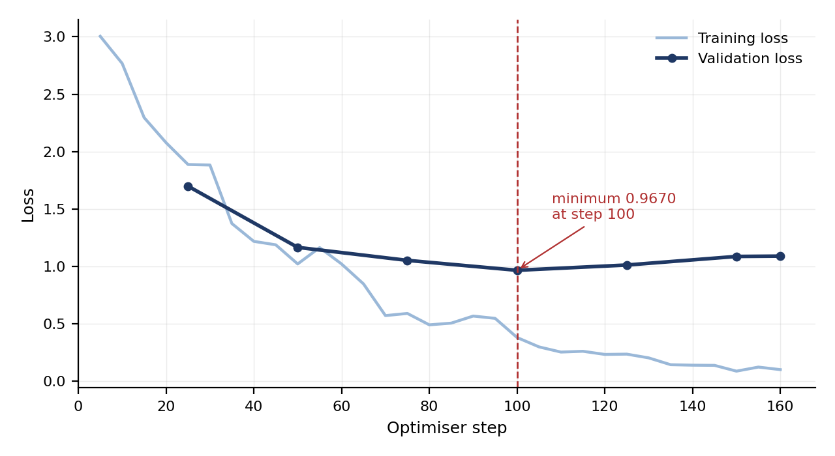
Figure 2: Training and validation loss over the 160-step run. Training loss keeps falling after the step-100 validation minimum; the final two epochs were kept deliberately, for the reason argued in this section.
Training loss fell throughout, averaging 0.86 and reaching 0.10 at the final step, while validation loss rose 13% above its step-100 minimum, which on an ordinary task is overfitting. The final two epochs were kept deliberately: the objective is memorising a fixed 54-fact knowledge base, and with no retrieval at inference every fact must be in the weights. Held-out loss is therefore a proxy, and §5.9 supplies the behavioural check.
A checkpoint retention limit of three kept steps 125, 150 and 160 and discarded step 100, the best by validation loss. Raising that limit is the fix for a second round.

5.8 Generation quality against the un-fine-tuned base
The graded comparison holds everything constant except the adapter: same base model, tokenizer, 63-item test split, greedy decoding and 4-bit load. Perplexity is computed over the whole split, the similarity metrics over the 52 answerable items.
Metric | Un-fine-tuned base | Fine-tuned | Change
Perplexity (lower is better) | 23.75 | 3.65 | ÷ 6.5
BLEU | 1.28 | 19.82 | ×15.5
chrF | 15.04 | 40.35 | ×2.7
ROUGE-L | 8.11 | 39.63 | ×4.9
BERTScore F1 | 64.28 | 78.29 | +14.0
Table 12: Similarity to the gold answer over the 52 answerable test items; perplexity is computed over the full 63-item split. BERTScore uses bert-base-multilingual-cased.
BLEU and chrF agree in direction, which is the check chrF was included to provide, since corpus BLEU over 52 short answers is noisy. BERTScore uses a multilingual encoder because the references are code-switched, so only the difference between columns is claimed, not the absolute values.
Improvement is not uniform across domains, and the pattern is informative.
Domain | Test items | BLEU base to tuned | ROUGE-L base to tuned
Malaysian slang and discourse particles | 15 | 0.96 to 33.29 | 9.89 to 51.84
Small talk | 10 | 2.87 to 23.04 | 17.90 to 52.83
JPJ – road tax and driving licences | 17 | 0.57 to 15.69 | 4.83 to 29.11
JPN – MyKad and birth certificates | 5 | 0.51 to 12.04 | 2.43 to 25.70
Immigration – passports | 5 | 0.53 to 4.40 | 0.00 to 26.30
Table 13: Per-domain similarity, best configuration. Register transfers more readily than fact recall.
The two strongest domains are those where the answer is mostly style; the weakest needs a specific number from the thinnest slice of training data. This is the expected shape for QLoRA on a small corpus, and argues for enlarging the passport domain rather than training longer.
All 11 refusal items share one gold answer, so any model that declines scores near-perfectly on them. The un-fine-tuned base wrongly declines 67% of in-domain questions, so including refusal rows would register over-refusal as accuracy. These metrics are therefore computed over the answerable items only; perplexity is the exception, since the fallback sentence is part of what the model was trained to produce.

5.9 Hallucination control and residual failures
Behaviour | Un-fine-tuned base | Fine-tuned
Out-of-scope declined, exact wording (11 items) | 18% | 82%
Out-of-scope declined, any wording (11 items) | 82% | 82%
In-domain wrongly declined (52 items) | 67% | 2%
Table 14: Refusal behaviour on the full test split. The middle row is the one most easily misread.
Read alone, the middle row of Table 14 says fine-tuning achieved nothing: both models decline 82% of out-of-scope questions. The third row is why that reading is wrong. The base reaches its figure by declining almost everything, including 67% of the questions it should have answered; it is not discriminating, it is close to mute. The measure of a working boundary is the gap: 15 percentage points for the base, 80 for the fine-tuned model.
On exact wording, fallback accuracy moved from 18% to 82% and over-refusal fell from 67% to 2%. Both changes were predicted in §5.6 as the reason for preferring this base model.
Two out-of-scope probes still leak, unequally. Asked to explain photosynthesis, the system did so correctly: the boundary leaked but nothing false was stated. Asked whether the user could sue an employer, it answered, incoherently. That is the failure category which disqualified the alternative base model, so the honest claim is that fine-tuning reduced it without eliminating it.
One in-domain question of 52 is still wrongly declined, though the fact it asks for is in both the knowledge base and the training split. That is a paraphrase-robustness miss, which is what §5.5 established the pair-level split can detect.

6.0 Coding
Complete source is in the project repository. The excerpts below are the components that carry the analytical argument above.

6.1 Language routing
app/stt.py. Base Whisper chooses the language token; the Malaysian checkpoint transcribes with it. The routing evidence is §5.3, and the constant that keeps transcription off the GPU is the one §3.5 argues for.
VANILLA_MODEL, MALAYSIAN_MODEL = "small", "mesolitica/malaysian-whisper-small-v3"
EN_THRESHOLD = 0.5
# Transcribe on the CPU even when a GPU is present: the demonstration card is
# 4 GB and Stage 3 needs ~3 GB of it. torch_dtype is float32 on either device,
# so the transcript -- and the reported 0.349 -- is unchanged (section 3.5).
STT_ON_GPU = os.getenv("BORAKBOT_STT_GPU") == "1"

def detect_language(audio: AudioInput) -> tuple[str, float]:
"""Choose the language token. Mesolitica's own detector always answers
Malay, so English clips come back translated at 0.788. Base Whisper's is
unbiased and costs one encoder pass; it only CHOOSES the token."""
m = _vanilla()
mel = whisper.log_mel_spectrogram(
whisper.pad_or_trim(whisper.load_audio(_as_path(audio))),
n_mels=m.dims.n_mels).to(m.device)
_, probs = m.detect_language(mel)
top, p_en = max(probs, key=probs.get), float(probs.get("en", 0.0))
# Asymmetric: forcing English on Malay audio is usually harmless but
# occasionally unbounded (one clip: 362 insertions on 7 reference words).
return ("en" if top == "en" and p_en > EN_THRESHOLD else "ms"), p_en

6.2 Corpus WER
archive/eval/speech/run_wer.py. The per-clip counts returned here are what Table 3's S/I/D columns are summed from, and §5.1 states why the corpus total is reported rather than the mean of per-clip rates.
def score_pair(ref: str, hyp: str, tf):
"""Return (counts, substitution pairs) for one clip."""
out = jiwer.process_words(ref, hyp, reference_transform=tf,
hypothesis_transform=tf)
errors = out.substitutions + out.deletions + out.insertions
n = out.hits + out.substitutions + out.deletions
return dict(errors=errors, n=n, sub=out.substitutions, ins=out.insertions,
dele=out.deletions), _aligned_substitutions(out)

def corpus_wer(df, col_err="errors", col_n="n"):
"""Total errors / total reference words -- not the mean of per-clip WERs,
which over-weights short utterances (section 5.1)."""
n = df[col_n].sum()
return df[col_err].sum() / n if n else float("nan")

6.3 Transcription repair
app/normalise.py. The rule for what may be repaired is the whole of the design; see §3.3. The table holds 17 entries in two groups, elided here and given in full in Appendix E.
# Every entry is a token Whisper produced that is not a word in Malay or
# English, or a spelling of a domain term the corpus never uses. Deliberately
# NOT included, though frequent: nampak->nak, look->dulu, good->kot, and->n,
# dengan->money, kad->credit. Each is a real word being mistranslated, and
# repairing it would corrupt the utterances where the word is correct.
ASR_REPAIRS: dict[str, str] = {
"jbj": "myjpj", "charanabuk": "nak", "unitrasca": "unit", # 12 invented
"chiamnna": "camne", ... # tokens in all
"ayo": "aiyo", "efilling": "efiling", "pasport": "passport", # 5 spelling
... # variants
}

def normalise(text: str) -> Normalised:
"""Stage 2. Tidy whitespace and punctuation, then repair by token-level
lookup. Case, wording and register are left alone; _TOKENS keeps the
separators so spacing survives, and _match_case gives "Jbj" -> "Myjpj"."""
fixed, changes = repair(tidy(text))
return Normalised(fixed, repairs=changes, changed=fixed != text.strip())

6.4 Knowledge-based generation
app/inference.py. Decoding settings are mirrored from eval/generate.py; if they drift, the demonstration stops being the thing this report measured. The loader implements the memory argument of §3.5, and the reply object is what lets the interface state which backend answered.
BASE_MODEL, ADAPTER = "meta-llama/Llama-3.2-3B-Instruct", "YongVay/borakbot-qlora-r1"
MAX_NEW_TOKENS, GREEDY, HISTORY_TURNS = 160, True, 2
# Every training example is a SINGLE turn, so multi-turn context is
# off-distribution by construction; history is capped at two turns.

def _load():
"""Base model in 4-bit where possible, adapter attached."""
four_bit = torch.cuda.is_available()
tok = AutoTokenizer.from_pretrained(BASE_MODEL)
if four_bit:
quant = BitsAndBytesConfig(load_in_4bit=True, bnb_4bit_quant_type="nf4",
bnb_4bit_compute_dtype=torch.float16,
bnb_4bit_use_double_quant=True)
try:
# Pin, do not spill. device_map="auto" does NOT fail on a short
# card: it quietly moves layers into system RAM, and the app would
# report cuda-4bit while running at a fraction of GPU speed.
model = AutoModelForCausalLM.from_pretrained(
BASE_MODEL, quantization_config=quant, device_map={"": 0})
except Exception: # deliberately broad: the GPU path is an
four_bit = False # optimisation, and ANY failure should end
model = cpu_bf16() # on the path that always works
else:
model = cpu_bf16()
return tok, PeftModel.from_pretrained(model, ADAPTER).eval(), four_bit

def answer(user: str, history=None) -> Reply:
"""Stage 3. Takes the NORMALISED utterance. The system prompt is read from
the knowledge base, not stored here: the same file stamps every training
example and is parsed by the evaluation harness, so training and serving
cannot drift."""
tok, model, four_bit = _model()
started = time.perf_counter()
enc = tok(tok.apply_chat_template(build_messages(user, history),
tokenize=False, add_generation_prompt=True),
return_tensors="pt").to(model.device)
with torch.no_grad():
out = model.generate(**enc, max_new_tokens=MAX_NEW_TOKENS,
do_sample=not GREEDY, # greedy, as evaluated
pad_token_id=tok.pad_token_id)
return Reply(text=tok.decode(out[0][enc["input_ids"].shape[1]:],
skip_special_tokens=True).strip(),
seconds=time.perf_counter() - started,
backend="cuda-4bit" if four_bit else "cpu-bf16")

6.5 Feedback capture
app/feedback.py. The moderation boundary is visible in the code: there is an export function and no retraining trigger, and the exported row is shaped like a training pair without being saved as one.
def log(user_text, reply, verdict, *, transcript=None, correction=None,
context=None, backend=None, seconds=None, db: Path = DB) -> int:
"""Record one verdict. transcript is stored apart from user_text so an ASR
failure stays distinguishable from an NLP one (section 3.1)."""
if verdict not in ("up", "down"):
raise ValueError(f"verdict must be 'up' or 'down', got {verdict!r}")
with _db(db) as conn:
cur = conn.execute(
"""INSERT INTO feedback (created_utc, transcript, user_text, reply,
verdict, correction, context, backend, seconds)
VALUES (?, ?, ?, ?, ?, ?, ?, ?, ?)""",
(datetime.now(timezone.utc).isoformat(timespec="seconds"),
transcript, user_text, reply, verdict, correction or None,
json.dumps(context or [], ensure_ascii=False), backend, seconds))
return int(cur.lastrowid)

def export_corrections(db: Path = DB) -> list[dict]:
"""Thumbs-down rows carrying a correction, shaped like a training pair --
shaped like one, not saved as one. A person reviews these before any of
them reaches data/generated/. There is no retraining trigger here."""
...

6.6 Repository structure
Path | Purpose
app/stt.py | Stage 1: language routing and transcription
app/normalise.py | Stage 2: transcription repair, with a self-test
app/inference.py | Stage 3: 4-bit base plus QLoRA adapter, generation
app/feedback.py | Stage 4: SQLite logging, review export
app/streamlit_app.py | Chat interface, voice and text
app/pages/admin.py | Password-gated feedback review
data/generated/ | Corpus and the train/validation/test splits
training/qlora_config.yaml | Fine-tuning configuration
eval/generate.py | Runs a model over a split and records what it said
eval/results/ | Committed result files behind every Stage 2 to 4 figure here
archive/eval/speech/run_wer.py | Stage 1: transcription across configurations, and WER scoring
archive/scripts/prompts/generate_pairs_prompt.md | The corpus generation prompt, retained as the provenance record
requirements.txt | Pinned runtime dependencies for the application and the harnesses
Table 15: Repository layout, principal files. The live application is four modules plus the Streamlit interface and the review page; everything else is data, evaluation or documentation. Stage 1 tooling has run and is retained under archive/, from where nothing is imported.

7.0 Results
The full evidence for every claim below is in the Algorithm Analysis. This section gathers the headline measurements and states, for each objective, whether it was achieved. The interface producing these outputs is shown in Appendix G.
Two evaluations were run and are kept apart. Stage 1 was measured by Word Error Rate over 48 purpose-recorded code-switched clips, 387 reference words. Stage 3 was measured on a held-out split of 63 question–answer pairs, against the same base model without the adapter. Stages 2 and 4 have no metric of their own and so have no subsection below: transcription repair is a seventeen-entry lookup whose scope is argued in §3.3 and listed in Appendix E, with its effect on a live turn visible in Figure 4, while feedback capture is a mechanism rather than a model, evidenced in Figures 6 to 9 and against Objective 6 in Table 17.

7.1 Headline measurements
Stage | Measure | Baseline | System as built | Detail
1. Speech-to-text | Corpus WER, strict | 0.618 | 0.349 | Table 3
1. Speech-to-text | Corpus WER, lenient | 0.615 | 0.339 | Table 3
1. Speech-to-text | Best switch type (ms_dom) | n/a | 0.155 | Table 7
1. Speech-to-text | Worst switch type (numeric) | n/a | 0.531 | Table 7
3. Generation | Perplexity | 23.75 | 3.65 | Table 12
3. Generation | BLEU | 1.28 | 19.82 | Table 12
3. Generation | chrF | 15.04 | 40.35 | Table 12
3. Generation | ROUGE-L | 8.11 | 39.63 | Table 12
3. Generation | BERTScore F1 | 64.28 | 78.29 | Table 12
3. Refusal | Out-of-scope declined, exact wording | 18% | 82% | Table 14
3. Refusal | In-domain wrongly declined | 67% | 2% | Table 14
3. Refusal | Discrimination gap between the two rates | 15 pts | 80 pts | Table 14
Table 16: Headline results. The Stage 1 baseline is the unassisted Malaysian checkpoint with no decoder prompt and no routing; the Stage 3 baseline is the same base model, test split and decoding settings with the adapter removed.

7.2 Stage 1: speech recognition
The best configuration reaches a corpus WER of 0.349 strict and 0.339 lenient, against 0.618 for the unassisted baseline: a 44% relative reduction. The decoder prompt is the largest single lever, worth 22 percentage points, and per-utterance language routing a further 5. A third contribution sits on a different axis and does not add to that chain: the Malaysian checkpoint is worth 5 points over base Whisper at equal prompt conditions.
The proposal's target of WER ≤ 0.25 was not met on the full corpus, and is reported as measured. An oracle analysis bounds what routing alone can achieve at 0.2765, so the remaining gap is not a routing problem: reaching 0.25 would also require number normalisation and Malaysian entity vocabulary. Published WER for code-switched ASR at this model size typically falls in the 0.30 to 0.50 range.
Error is not evenly distributed. Malay-dominant speech, discourse particles and true intra-sentential mixing are all at or below 0.234, while numeric and English-dominant utterances carry most of the error. These are not equivalent failures: numeric error is largely a scoring artefact arising outside the system, whereas the English-dominant figure is a component of this system failing.

7.3 Stage 3: generation and hallucination control
Fine-tuning improved every similarity metric, and the two included as a cross-check on each other (BLEU at word level, chrF at character level) agree in direction. Perplexity fell by a factor of 6.5.
The hallucination-control result most repays careful reading. Both models decline roughly 82% of out-of-scope questions, which alone suggests fine-tuning achieved nothing. That reading is wrong: the un-fine-tuned base reaches that rate by declining almost everything, including 67% of the questions it should have answered. The measure of a working knowledge boundary is the gap between the two refusal rates, and it moved from 15 percentage points to 80. Fallback accuracy rose from 18% to 82% and over-refusal fell from 67% to 2%.
Two out-of-scope probes still leak, and one matters: asked whether the user could sue an employer, the system answered rather than declining. That is the failure category which disqualified the alternative base model, so the honest claim is that fine-tuning reduced it without eliminating it.

7.4 Achievement against the project objectives
# | Objective (proposal §4) | Achieved | Evidence
1 | Accept Malay–English code-switched input, as text and as speech | Yes | Typed rojak, in-browser recording and uploaded audio all accepted; Stage 1 evaluated at 0.349 WER (§5.1-5.4)
2 | Reply in the same rojak register | Yes, by automatic metrics | BLEU 1.28 → 19.82, chrF 15.04 → 40.35, ROUGE-L 8.11 → 39.63 (§5.8).
3 | Keep replies knowledge-based, declining rather than inventing | Substantially | Discrimination gap 15 → 80 points; over-refusal 67% → 2%. Two of eleven out-of-scope probes still leak (§5.9)
4 | Integrate speech-to-text so users can converse by voice | Yes | Voice path runs end to end: recording or upload, transcription, then Stage 2 repair before generation (§3.1, §3.5)
5 | Embed the knowledge base by fine-tuning, no retrieval at inference | Yes | 632-pair corpus from 54 verified facts; ~24 MB QLoRA adapter over a frozen 4-bit base; perplexity 23.75 → 3.65 (§5.5, §5.7-5.8)
6 | Capture user corrections for moderated retraining | Yes, as designed | Verdicts and corrections logged to SQLite with dialogue context; export for review with no automatic write path (§3.1)
7 | Evaluate with appropriate quantitative metrics, speech errors reported apart from NLP errors | Yes | Two independent harnesses; WER over 48 clips, generation over 63 held-out pairs, never combined
Table 17: Project objectives and the evidence for each. The optional text-to-speech component named in the proposal was not built.
Six of the seven objectives are met. Objective 3 is met substantially rather than completely, and the residual failures are reported in §5.9 rather than omitted.

8.0 Discussion and Conclusion

8.1 What the findings mean
Four findings from this project generalise beyond it.
In-domain decoder context matters more than model choice for code-switched ASR. Four lines of rojak as decoder context were worth 22 percentage points of WER, four times the benefit of swapping in a Malaysian-fine-tuned checkpoint. The prompt is not an instruction; it shifts the decoder's language-model prior where the audio is ambiguous. Its composition mattered as much as its presence, since a predominantly Malay prompt pushed English-dominant utterances into translation.
The bottleneck was language identification, not transcription. The Malaysian checkpoint transcribes English competently when told to (0.106 under a forced English token), but its own detector always lands on Malay, so those clips came back translated at 0.788. What remains is calibration: a 0.5 confidence threshold is a sensible default for monolingual audio and the wrong scale for English sentences carrying Malay particles.
A refusal rate is not a measure of a knowledge boundary. A model that declines everything scores excellently on out-of-scope refusal and is useless; only the gap between out-of-scope and in-domain refusal rates describes a boundary. The same reasoning is why refusal items were excluded from BLEU, ROUGE-L and BERTScore, since all eleven share one gold answer.
Validation loss was the wrong quantity to optimise to completion. It bottomed out at step 100 and rose 13% by the end, which normally means overfitting. The objective here was memorising a fixed 54-fact knowledge base with no retrieval at inference, so held-out loss measures paraphrase robustness on facts already seen: a proxy, not the goal. Over-refusal collapsed and fallback accuracy rose across exactly the epochs in which validation loss was deteriorating.

8.2 Strengths of the solution
The evaluation is the strongest part of this work. Every reported figure is produced by committed code over committed data and can be regenerated; no number was hand-copied into the report. The speech test set is stratified by switch type with speakers balanced within each category, and that design is what made a speaker-dependent detection effect visible at all.
Design decisions were settled by measurement rather than intuition. The base model was chosen against a competitor that read as more fluent, on the ground that over-refusal from ignorance was repairable and fabrication was not; §5.9 shows the prediction held. Stage 2 was rewritten away from the proposal's design because 73% of training inputs proved to be informal rojak.
The moderated feedback loop was vindicated in use rather than in principle. The first correction ever logged was a negative verdict on a correct refusal, and applied automatically it would have eroded the boundary the project spends most of its evaluation measuring.
The system is also honest about its limits in operation: the interface reports which backend produced each reply and how long it took, and the speech model is pinned to the CPU so Stage 3 keeps the 4 GB of video memory.

8.3 Limitations
No human ratings were collected. Perplexity, BLEU, chrF, ROUGE-L and BERTScore all measure agreement with a written gold answer. None measures whether a reply is natural rojak, which is what Objective 2 claims. The Likert instrument is specified and its blinded rating sheet can be generated by the harness, but it was not administered. This is the single largest gap in the evaluation.
The test split shares its knowledge with the training split. The corpus was split at the level of the pair, not the fact, so every generation figure describes paraphrase robustness and must not be read as generalisation to new knowledge.
Small samples throughout. 48 clips and 387 reference words for speech; 52 answerable and 11 out-of-scope items for generation, where one item moves the refusal rate by nine percentage points. Per-category and per-domain figures rest on as few as five items.
Self-authored evaluation data, recorded by two speakers. The team wrote the knowledge base, generated the corpus from it and recorded the speech test set, so the held-out split shares authorship and register with the training data. Both speakers are team members reading sentences they wrote, in quiet rooms: real users will be less fluent, and spontaneous speech carries disfluencies and noise this set does not represent.
Speaker-dependent language detection. Every clip routed to English belongs to one speaker, and none of the other speaker's 24 clips crossed the threshold in any category (mean p_en 0.136 against 0.043). With four clips per speaker per category this is an observation rather than a demonstrated effect, but it means the en_dom result is in part a property of who recorded the corpus.
A single training run and two entangled safeguards. One seed and one configuration, so no variance estimate exists. Refusal is enforced twice, by the trained weights and by the system prompt, and both were active in every measurement, so the contribution of each is unknown. Coverage is also thin: all five JPN facts concern a lost MyKad and all five Immigration facts concern renewal. The optional text-to-speech component was not built.
Future work. Six improvements follow from the limitations above. Administer the specified Likert instrument, so rojak naturalness is rated by people rather than inferred. Recruit speakers outside the team, to separate detector calibration from speaker accent. Recalibrate the English-detection threshold on a held-out tuning set. Add a number normaliser, the largest remaining source of speech error. Broaden the thin JPN and Immigration domains and enlarge the professional-advice refusal category. And run a second retraining round through the moderated correction loop, raising the checkpoint retention limit so the best checkpoint survives.

8.4 Conclusion
BorakBot accepts Bahasa Rojak as speech or text, transcribes it with a language-routed Malaysian Whisper pipeline, repairs transcription errors without disturbing the register, answers from a knowledge base embedded in the model's weights, declines what it was not taught, and logs corrections for moderated retraining. All four stages are implemented, integrated and evaluated; six of seven objectives are met and the seventh substantially.
Two headline numbers describe the outcome. Speech recognition improved 44% relative to an unassisted baseline, to a WER of 0.349, short of the 0.25 targeted and reported as measured. Generation improved on every similarity metric, most consequentially in hallucination control, where the refusal gap widened from 15 percentage points to 80.
The more transferable contribution is methodological. Several results here would have been reported wrongly under the obvious reading: the refusal rate that credits a near-mute model, the validation curve that says stop at step 100, the substitution table that cannot be reversed into a repair table, the threshold optimum sitting beside a cliff. In each case the correct interpretation came from measuring the thing itself rather than a convenient proxy.

9.0 References
Chen, H., Liu, X., Yin, D., & Tang, J. (2017). A survey on dialogue systems. ACM SIGKDD Explorations Newsletter, 19(2), 25-35.
Dettmers, T., Pagnoni, A., Holtzman, A., & Zettlemoyer, L. (2023). QLoRA: Efficient finetuning of quantized LLMs. Advances in Neural Information Processing Systems, 36.
Devlin, J., Chang, M.-W., Lee, K., & Toutanova, K. (2019). BERT: Pre-training of deep bidirectional transformers for language understanding. Proceedings of NAACL-HLT 2019, 4171-4186.
Grattafiori, A., et al. (2024). The Llama 3 herd of models. arXiv:2407.21783.
Hu, E. J., Shen, Y., Wallis, P., Allen-Zhu, Z., Li, Y., Wang, S., Wang, L., & Chen, W. (2021). LoRA: Low-rank adaptation of large language models. arXiv:2106.09685.
Khalip, K. I., Ku Khalif, K. M. N., Mohd Aziz, M. K. B., & Gegov, A. (2025). Sentiment analysis of noisy Malay text using a large language model. Proceedings of the International Exchange and Innovation Conference on Engineering & Sciences, 11, 1904-1909.
Lewis, P., Perez, E., Piktus, A., Petroni, F., Karpukhin, V., Goyal, N., Küttler, H., Lewis, M., Yih, W., Rocktäschel, T., Riedel, S., & Kiela, D. (2020). Retrieval-augmented generation for knowledge-intensive NLP tasks. Advances in Neural Information Processing Systems, 33, 9459-9474.
Lim, H. T., Huspi, S. H., & Ibrahim, R. (2021). A conceptual framework for Malay-English mixed-language question answering system. 2021 International Congress of Advanced Technology and Engineering (ICOTEN).
Lin, C.-Y. (2004). ROUGE: A package for automatic evaluation of summaries. Text Summarization Branches Out, 74-81.
Mesolitica. (2025). malaysian-whisper-small-v3 [Model]. Hugging Face. https://huggingface.co/mesolitica/malaysian-whisper-small-v3
Morris, A. C., Maier, V., & Green, P. (2004). From WER and RIL to MER and WIL: improved evaluation measures for connected speech recognition. Proceedings of Interspeech 2004, 2765-2768.
Papineni, K., Roukos, S., Ward, T., & Zhu, W.-J. (2002). BLEU: A method for automatic evaluation of machine translation. Proceedings of ACL 2002, 311-318.
Popović, M. (2015). chrF: Character n-gram F-score for automatic MT evaluation. Proceedings of the Tenth Workshop on Statistical Machine Translation, 392-395.
Post, M. (2018). A call for clarity in reporting BLEU scores. Proceedings of the Third Conference on Machine Translation, 186-191.
Radford, A., Kim, J. W., Xu, T., Brockman, G., McLeavey, C., & Sutskever, I. (2023). Robust speech recognition via large-scale weak supervision. Proceedings of the 40th International Conference on Machine Learning, 28492-28518.
Shamsuddin, A. M., Juan, S. S., Chua, S., & Bramantoro, A. (2024). Semi-automatic sentiment identification for Malay-English code-switched data. Journal of Advanced Research Design, 123(1), 198-212.
Sitaram, S., Chandu, K. R., Rallabandi, S. K., & Black, A. W. (2020). A survey of code-switched speech and language processing. arXiv:1904.00784.
Taori, R., Gulrajani, I., Zhang, T., Dubois, Y., Li, X., Guestrin, C., Liang, P., & Hashimoto, T. B. (2023). Stanford Alpaca: An instruction-following LLaMA model [Computer software]. https://github.com/tatsu-lab/stanford_alpaca
Vaessen, N. (2022). jiwer: Evaluate an automatic speech recognition system [Computer software]. https://github.com/jitsi/jiwer
Wang, Y., Kordi, Y., Mishra, S., Liu, A., Smith, N. A., Khashabi, D., & Hajishirzi, H. (2023). Self-Instruct: Aligning language models with self-generated instructions. Proceedings of ACL 2023, 13484-13508.
Winata, G. I., Cahyawijaya, S., Liu, Z., Lin, Z., Madotto, A., & Fung, P. (2021). Are multilingual models effective in code-switching? Proceedings of the Fifth Workshop on Computational Approaches to Linguistic Code-Switching, 142-153.
Wolf, T., Debut, L., Sanh, V., et al. (2020). Transformers: State-of-the-art natural language processing. Proceedings of EMNLP 2020: System Demonstrations, 38-45.
Zhang, T., Kishore, V., Wu, F., Weinberger, K. Q., & Artzi, Y. (2020). BERTScore: Evaluating text generation with BERT. International Conference on Learning Representations.
Zheng, Y., Zhang, R., Zhang, J., Ye, Y., Luo, Z., Feng, Z., & Ma, Y. (2024). LLaMA-Factory: Unified efficient fine-tuning of 100+ language models. Proceedings of ACL 2024 (System Demonstrations).
Zolkepli, H. (2018). Malaya: Natural language toolkit for the Malaysian language [Computer software]. https://github.com/malaysia-ai/malaya

Appendices

Appendix A: Declaration of AI tool assistance
In accordance with TARUMT academic integrity policy, the following use of AI tools is declared:
Generated training data. The 632 question-answer pairs in the training corpus were generated by a large language model, prompted with the team-written knowledge base, topic definitions and style constraints. The generation prompt is retained in the repository at archive/scripts/prompts/generate_pairs_prompt.md as the provenance record. The knowledge base itself, all 54 facts with their sources and stability markers, was written and verified by the team against agency portals; no fact was accepted from a model. Generated pairs were filtered automatically for duplication, sentence count and emoji, and a sample from every category was read by a team member.
Coding assistance. An AI coding assistant was used during implementation of the evaluation harnesses, the Colab notebooks and the Stage 2 to 4 application modules, and in drafting sections of this report from the committed result files. All configuration values, evaluation results and reported figures were produced by running the code, not by a model asserting them; the result files behind every table are committed and can be regenerated.
Not generated. The speech test set, its 48 reference transcripts and the recordings themselves were authored and recorded by the team. The stratification design, the language-routing diagnosis, the choice of base model and the interpretation of every result in this report are the team's own.

Appendix B: Prompt text used for decoder conditioning
This text is supplied as preceding context to bias decoder output toward code-switched orthography. It shares no sentence or distinctive vocabulary with the test set; overlap would let the model copy from its own context and inflate every reported figure.
cuaca panas gila hari ni kan, tak larat nak keluar.
can you send me the file later, i need to check something first.
eh awak dah reply that email ke belum lah.
so how ah, do you want to join us or not.

Appendix C: Orthography map (lenient scoring)
Reference form | Canonical form | Justification
cek | check | Malay orthography of an English loanword
akaun | account | Malay orthography of an English loanword
klinik | clinic | Malay orthography of an English loanword
ayo | aiyo | Spelling variant of a discourse interjection
bil | bill | Malay orthography of an English loanword
lesen / license | licence | Orthographic variant
Table 18: Spelling variants canonicalised before lenient scoring. Translations are excluded.

Appendix D: Test set categories and speaker allocation
Each category contains eight utterances, four recorded by each team member, so that speaker is never confounded with switch type. Two utterances per category are reproduced below, one from each speaker; the full 48 are in the manifest.
ID | Category | Speaker | Reference transcript
s01_yv | ms_dom | yv | macam mana nak apply lesen memandu baru
s05_pq | ms_dom | pq | camne nak transfer duit guna online banking
s09_yv | en_dom | yv | how do i check my epf balance ah
s13_pq | en_dom | pq | is it safe to invest in unit trust ke
s17_yv | balanced | yv | saya dah submit application tapi belum dapat approval lagi
s21_pq | balanced | pq | saya nak update alamat kat identity card
s25_yv | particles | yv | eh betul ke ni macam tak kena je lor
s29_pq | particles | pq | so how ah nak buat macam mana ni
s33_yv | numeric | yv | harga dia empat puluh lima ringgit sembilan puluh sen termasuk cukai ke tak
s37_pq | numeric | pq | interest rate dia three point five percent setahun je
s41_yv | entity | yv | macam mana nak renew roadtax kat MyJPJ
s45_pq | entity | pq | nak apply MyKad baru kat JPN macam mana
Table 19: Representative utterances from the 48 evaluated, with switch type and speaker. The complete set, and the reciprocal phase-2 recordings of the same sentences by the other speaker, are in archive/eval/speech/manifest.csv.

Appendix E: Transcription repair table
The 17 entries applied by Stage 2. The rule for inclusion is that the token cannot legitimately occur in Malaysian rojak, either because Whisper invented it or because it is a spelling of a domain term the corpus never uses.
Whisper wrote | Repaired to | Why it is safe to repair
jbj | myjpj | Invented token; cannot occur in a correct transcript
charanabuk | nak | Invented token; cannot occur in a correct transcript
unitrasca | unit | Invented token; cannot occur in a correct transcript
maham | mahal | Invented token; cannot occur in a correct transcript
mora | murah | Invented token; cannot occur in a correct transcript
chiamnna | camne | Invented token; cannot occur in a correct transcript
naklam | nak | Invented token; cannot occur in a correct transcript
jepya | jpn | Invented token; cannot occur in a correct transcript
bernil | renew | Invented token; cannot occur in a correct transcript
lemala | lemak | Invented token; cannot occur in a correct transcript
identi | identity | Invented token; cannot occur in a correct transcript
autor | auto | Invented token; cannot occur in a correct transcript
ayo | aiyo | Orthographic variant; the corpus uses one spelling
efilling | efiling | Orthographic variant; the corpus uses one spelling
pasport | passport | Orthographic variant; the corpus uses one spelling
license | licence | Orthographic variant; the corpus uses one spelling
lho | lor | Orthographic variant; the corpus uses one spelling
Table 20: Transcription repairs applied before generation.
The following high-frequency substitutions were deliberately excluded, because each is a real word being mistranslated and repairing it would corrupt the utterances where the word is correct.
Whisper wrote | Came from | Why it cannot be repaired
saya | can (9), do (6), i (6), balance (5), my (4) | Five different sources; no single repair is right
card | roadtax (6), mykad (6) | Ambiguous between two domains
buku | pukul (8), tutup (2) | buku is also the word for book
nampak | nak (7) | nampak is a common word in its own right
and | n (7) | Repairing would replace a correct word with an abbreviation
Table 21: Substitutions deliberately not repaired.

Appendix F: System prompt
Read from data/knowledge_base/_system_prompt.md by the training converter, the evaluation harness and the application, so that the text cannot drift between training, measurement and demonstration.
Kamu BorakBot, chatbot yang jawab soalan pasal urusan kerajaan dan admin harian
Malaysia: roadtax dan lesen memandu (JPJ), MyKad dan sijil lahir (JPN), passport
(Imigresen), dan boleh sembang santai serta terangkan maksud slanga Malaysia.

Cara jawab:
- Cakap Bahasa Rojak (campur Melayu-Inggeris) macam kawan Malaysia. Santai,
mesra, guna particle macam "lah", "eh", "kan" bila natural.
- Jawab ringkas. Dua tiga ayat cukup.
- Kalau soalan tu pasal domain kau, jawab terus dengan fakta yang kau tahu.

Bila kau TAK BOLEH jawab:
- Soalan luar domain (contoh: sains, sukan, masakan, movie)
- Harga atau nilai live (contoh: harga bitcoin, kadar tukaran wang, cuaca)
- Maklumat peribadi user (contoh: status permohonan passport dia, bila roadtax
dia expired)
- Berita atau kejadian terkini
- Nasihat perubatan, undang-undang, atau pelaburan

Untuk semua kes di atas, jawab: "Maaf, saya tak pasti pasal tu lah, boleh tanya
benda lain tak?"

Jangan reka fakta. Kalau tak pasti, guna ayat maaf tu. Lebih baik mengaku tak
tahu daripada bagi jawapan salah.

Appendix G: Prototype Interface
The screenshots below show the delivered prototype exercising each of the four stages described in §3.1, captured on the GPU machine so that the backend and latency captions match the configuration this report measures. Every figure shown in the sidebar is read from the committed result files rather than typed into the interface.
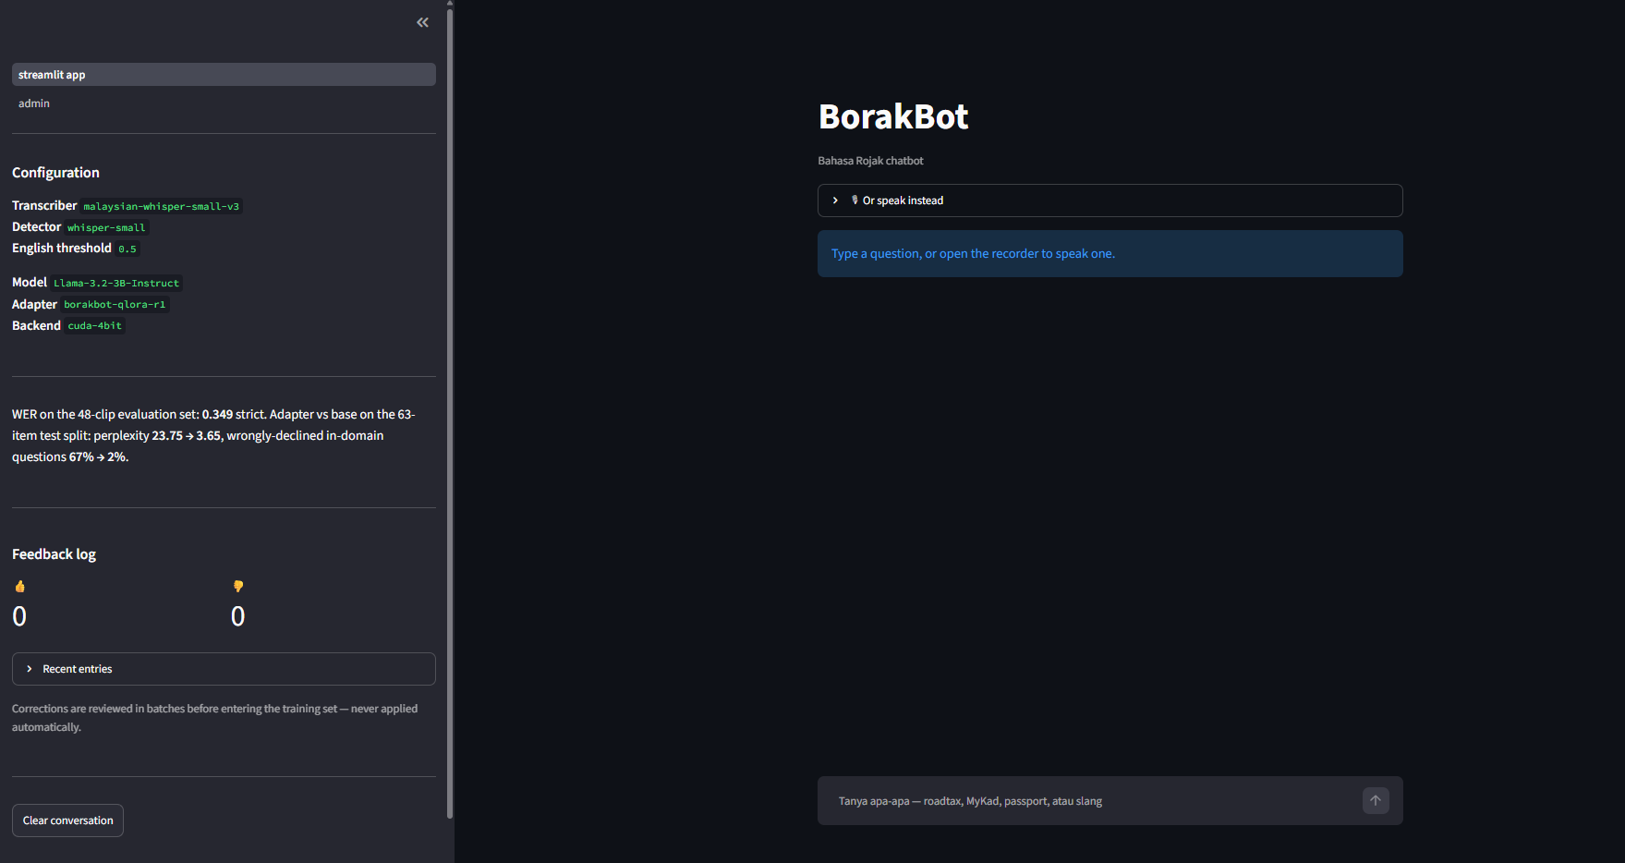
Figure 3: The chat page at rest. The sidebar states the active configuration, the corpus WER of §5.4 and the running feedback tally, so anyone watching a demonstration can see which pipeline produced what.

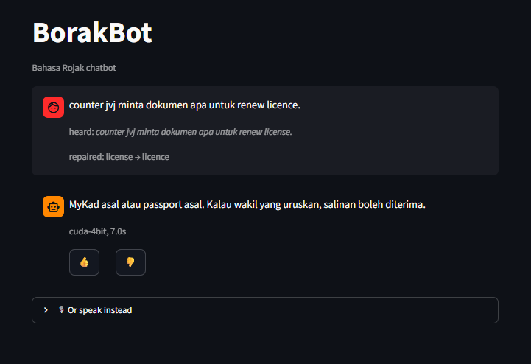
Figure 4: A voice turn answered from the knowledge base. The heard: caption is the Stage 1 transcript and repaired: records the single Stage 2 substitution applied to it (license → licence, Appendix E); the reply carries the backend and the latency that produced it.

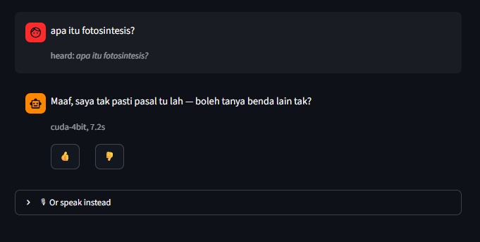
Figure 5: An out-of-scope question receiving the trained fallback sentence rather than an invented answer. This is the behaviour measured in Table 14.

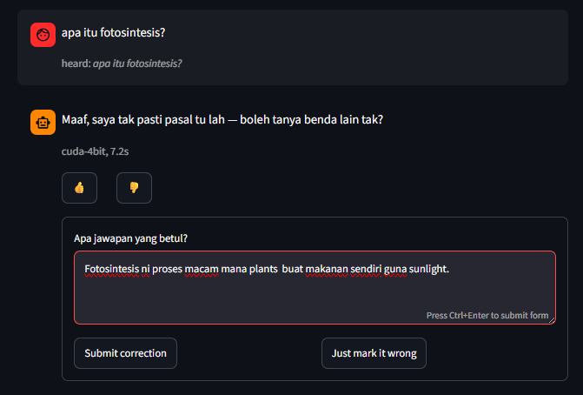
Figure 6: A negative verdict opening the correction field. This is the exchange described in §8.2: the refusal was correct and the correction offered against it was not, which is why no correction is applied automatically.
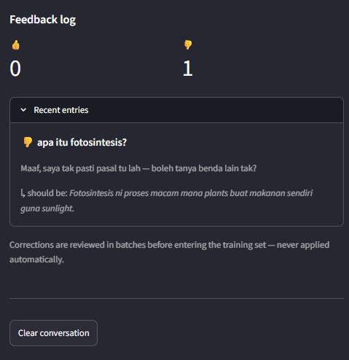
Figure 7: The sidebar feedback log after that verdict, showing the question, the rejected reply and the correction the tester supplied.
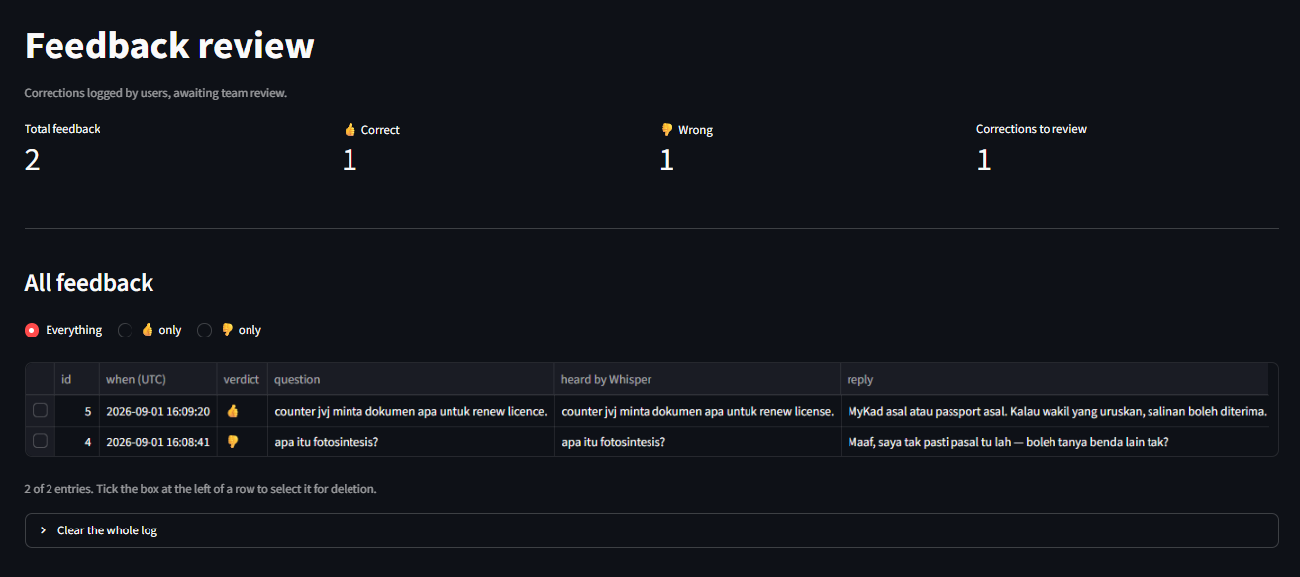
Figure 8: The password-gated review page. question and heard by Whisper are stored in separate columns so that a wrong answer to a misheard question stays attributable to Stage 1 rather than to generation (§3.1).

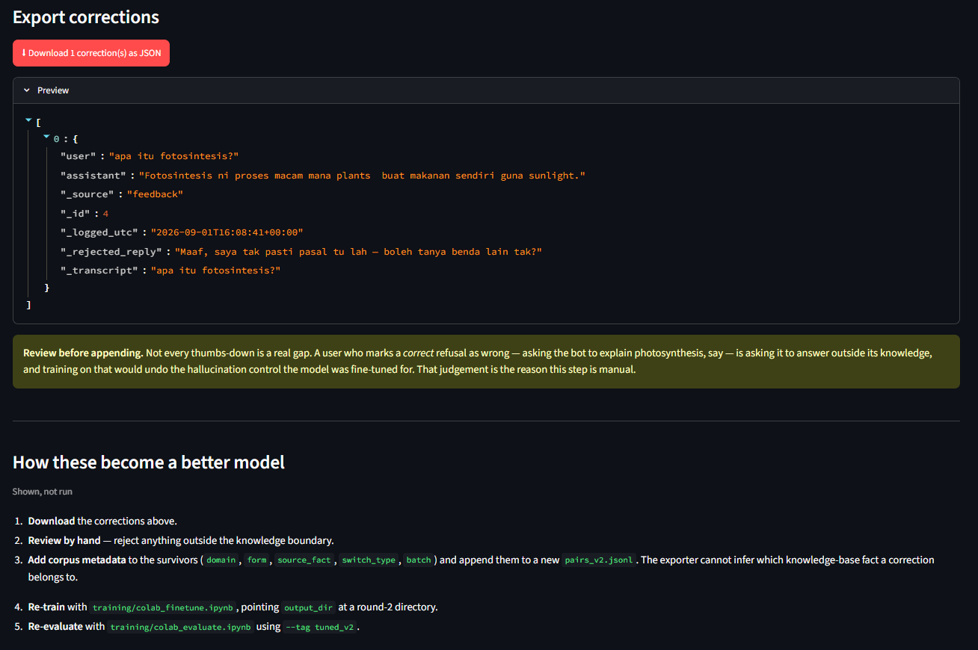
Figure 9: Corrections exported as review-ready training pairs. There is no automatic write path into the training data: the export, and the manual steps listed beside it, are the moderation boundary of §4.5.

